# Koraci za pokretanje projekta

<https://github.com/adil-fit-ba>

-> rs1-2024-25

-> RS1_2024_25_template_1 --------- ovdje se nalazi **vs projekat** i **angular projekat**

<https://bit.ly/rs1-fit> ->2024-25 --> sedmica 06 -> ovaj word dokument

preuzeti novu verziju koda sa github.

Koristiti opciju **pull**

**Backend**

**1—provjeriti ssms**

**2—ispraviti po potrebi connection u appsettings.json**

**3—start vs projekat**

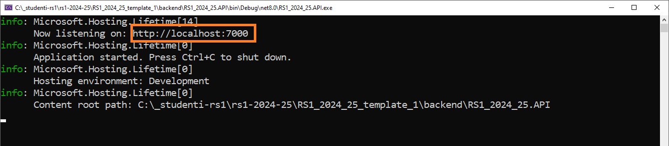

**4—otvorit u webbrowseru localhost:7000**

**5—stopirati backend aplikaciju**

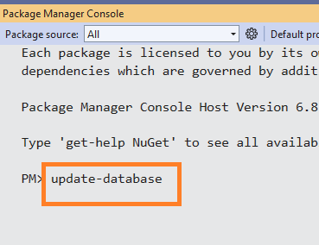

**Kreira se db i tabele (Ako je konekcija na db ispravna)**

**6—ako su db i tabele uspješno kreirane -> pokrećemo ponovo app i otvaramo akciju za generisanje podataka**

**7🡪 ako su podaci generisani (znaci konekcija na db radi) onda testirati api za prikaz, dodavanje, editovanje i brisanje cities.**

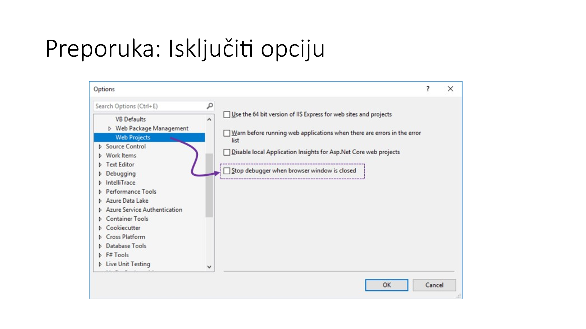

# Koraci za dodavanje nove tabele

1. **Dodati novu klasu u Data\Models**
   1. **Dodati primarni kljuc sa anotacijom [Key]**

|  |
| --- |
| [Key]  public int ID { get; set; } |

* 1. **Dodati strane kljuceve**

|  |
| --- |
| [ForeignKey(nameof(Country))]  public int CountryId { get; set; }  public CountryKlasa? Country { get; set; } |

**Žuto označeva vrijednost mora biti identična na sva 3 mjesta**

* 1. **Na vježbama neće koristiti Liste (kolekcije) objekata jer su oni pomoćni atributi, i ne mijenjaju strukturu DB-a**

1. **Dodati novi tabelu u ApplicationDbContext**
2. **Generisati skriptu za migraciju**

1. **Izvršiti skriptu –**

# Naslijeđivanje

# Endpoint

**\*\*Adil:** Opis klase **MyEndpointBaseAsync** je u istom imenom poglavlju unutar ovog word dokumenta.

**

# MyAuthService

**

**Alternativa za MyAuthorizationAttribute**

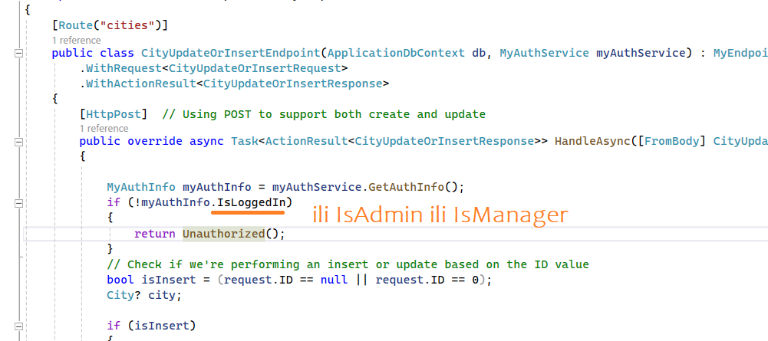

**

# Program.cs

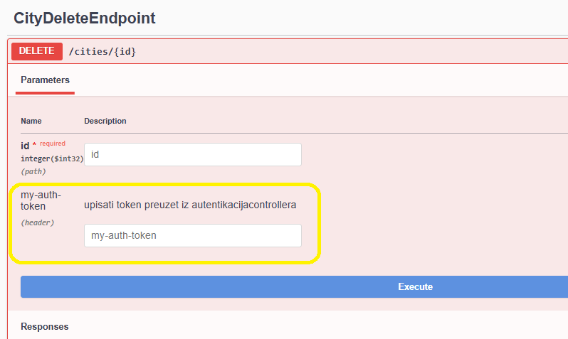

# Async

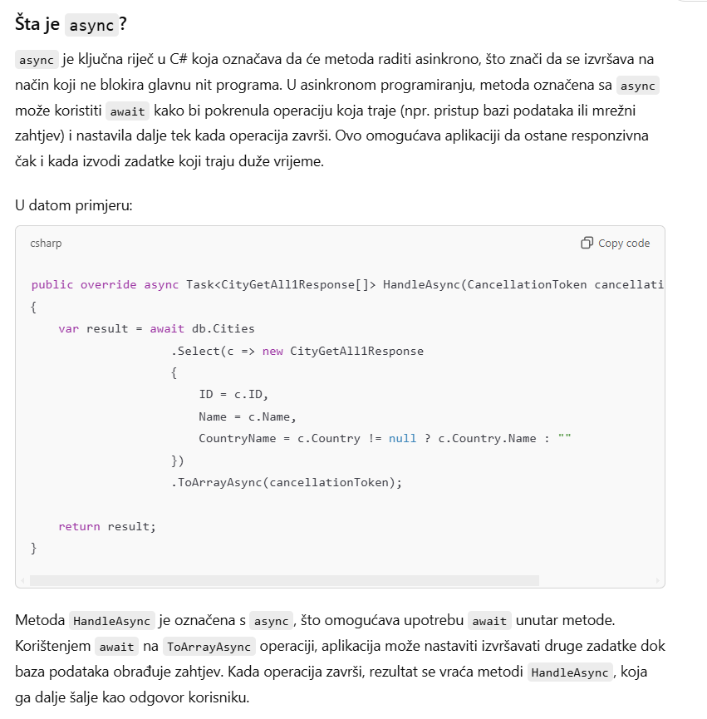

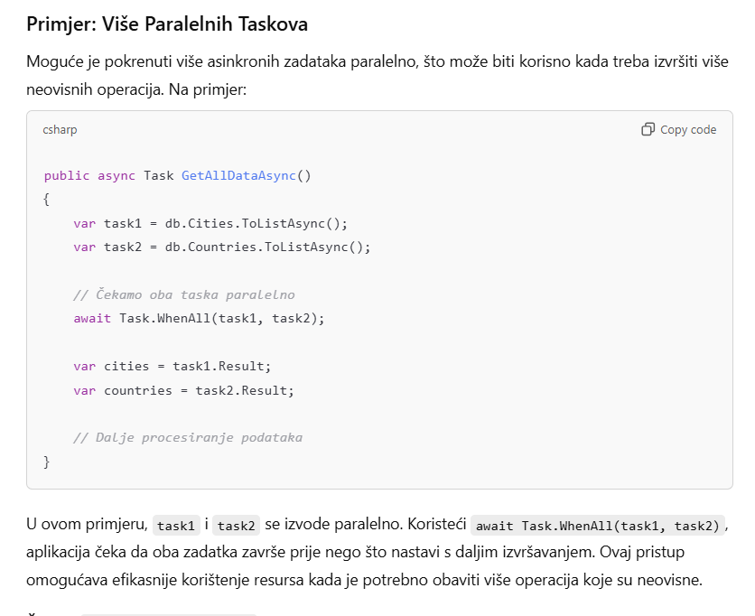

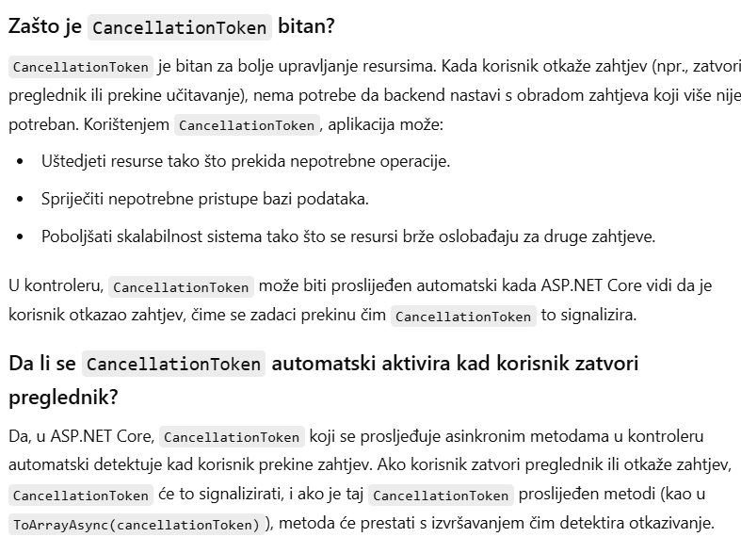

# ToArray umjesto ToList

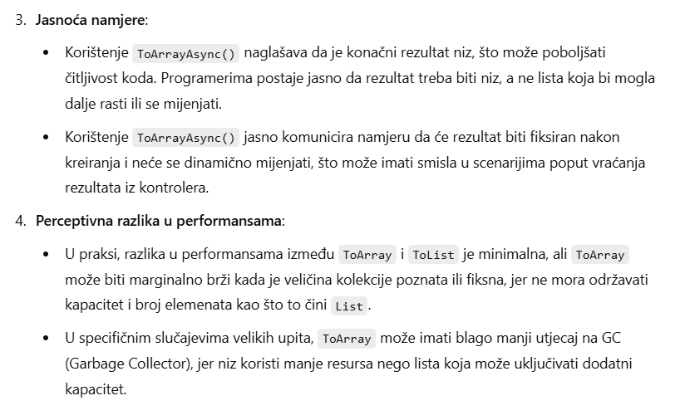

# Primjer složenih upita - sa i bez kolekcije u many-to-one

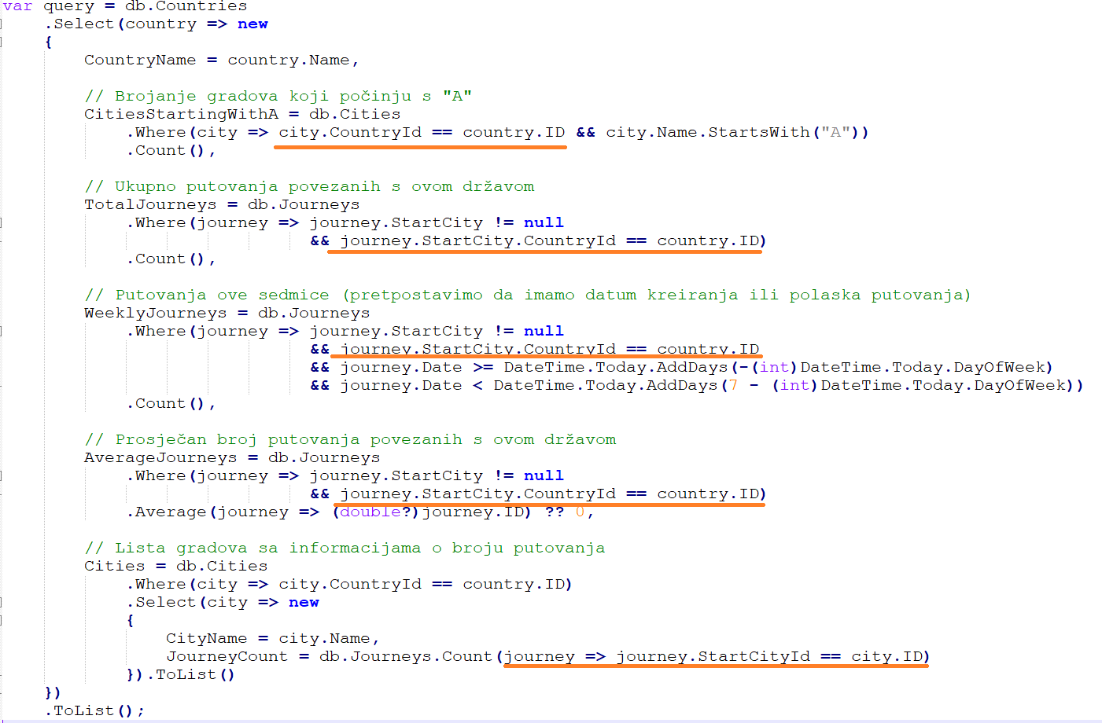

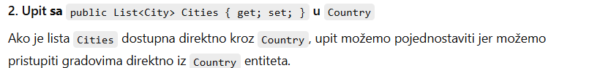

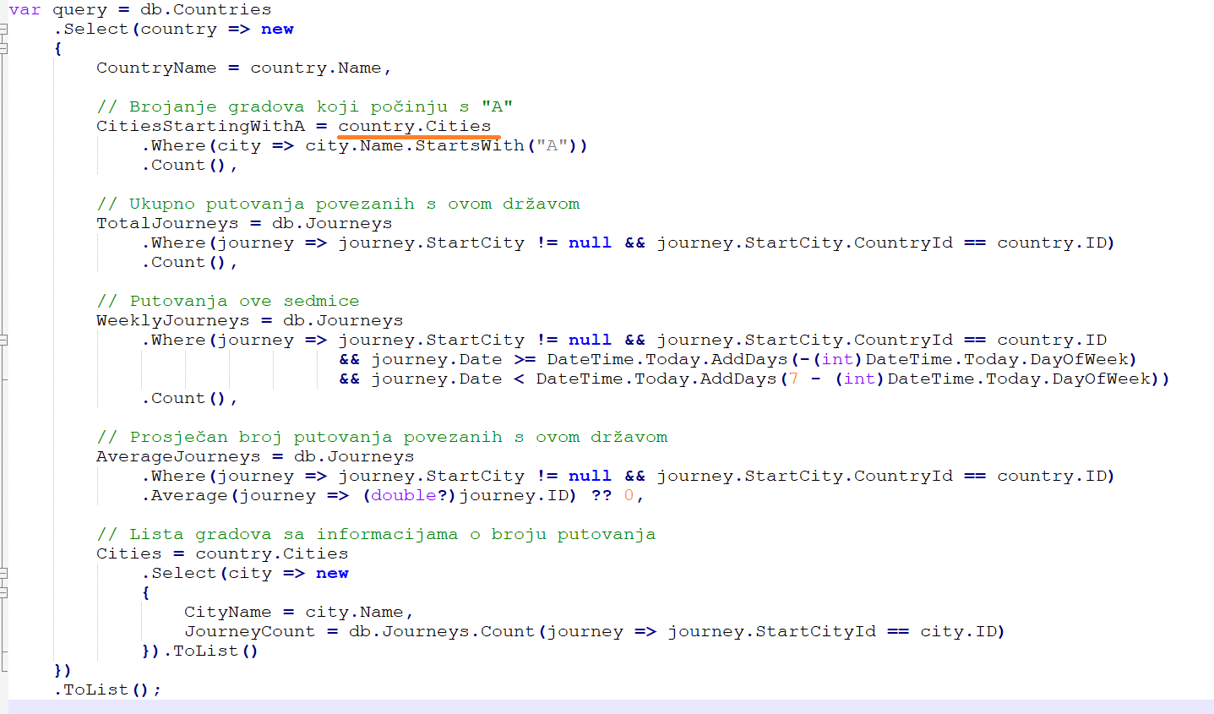

# AppUser

## Bez klase Role

## Sa klasom Role

## Tabele Client i Employee

